Date of Application: ______________________ Desired Start Date: ________________________

Child's Information
Full Name (Including Middle): _____________________________________________________
Nickname or another name the child goes by: _____________________________________________
Address: ______________________________ City: ______________________ Zip: ___________
Home Phone: _____________________________ Alternate Number: _________________________
Gender: _____________ Date of Birth: ____________________ Current Age: __________________
Child lives with: _____ Mother & Father _____ Mother _____ Father ____ Legal Guardian
Has child previously attended a preschool or childcare? ______ If so, where? ______________
If your child’s clothes become soiled, would you like us to wash them? _____Yes ______No
Parent’s Information
Parents are:
_____ Married _____ Living Together _____Divorced _____ Separated ___Widowed
If divorced, who has legal custody? _____ Mother _____ Father _____ Both
May the non-custodial parent pick up the child? Yes / No ** If no, you must provide legal documentation.
Mother’s Full Name: __________________________________________________________
Address: _______________________________ City: __________________ Zip: ___________
Home Phone: ___________________ Cell Phone: _______________ Cell Carrier: _________
Work Phone: ______________________ Employer: __________________________________
Email Address: _______________________________________________________________
Father's Full Name: ___________________________________________________________
Address: _______________________________ City: ___________________ Zip: __________
Home Phone: ___________________ Cell Phone: _______________ Cell Carrier: _________
Work Phone: _____________________ Employer: ___________________________________
Email Address: _______________________________________________________________
Legal Guardian's Name {if applicable}: ______________________________________________
Address: _______________________________ City: ___________________ Zip: __________
Home Phone: _____________________ Cell Phone: _______________ Cell Carrier: ________
Work Phone: _____________________ Employer: ___________________________________
Email Address: _______________________________________________________________

Parent/Legal Guardian Signature: ____________________________________ Date: _______

Emergency Contacts
Name three people who should assume responsibility for your child if Parents/Guardian cannot be reached.
Full Name: ____________________________________ Phone: ________________________
Address: ___________________________________ City: _______________ Zip: __________
Relationship to child: _________________________ Alternate Phone: ____________________

Full Name: ____________________________________ Phone: ________________________
Address: ___________________________________ City: _______________ Zip: __________
Relationship to child: _________________________ Alternate Phone: ____________________

Full Name: ____________________________________ Phone: ________________________
Address: ___________________________________ City: _______________ Zip: __________
Relationship to child: _________________________ Alternate Phone: ____________________

Authorized Pickups
I hereby authorize Think Play Grow Academy to allow my child to leave the facility with ONLY the following persons (they are in addition to the Emergency Contacts):

Full Name: ____________________________________ Phone: ________________________
Address: ___________________________________ City: _______________ Zip: __________
Relationship to child: _________________________ Alternate Phone: ____________________
Full Name: ____________________________________ Phone: ________________________
Address: ___________________________________ City: _______________ Zip: __________
Relationship to child: _________________________ Alternate Phone: ____________________
Full Name: ____________________________________ Phone: ________________________
Address: ___________________________________ City: _______________ Zip: __________
Relationship to child: _________________________ Alternate Phone: ____________________
Full Name: ____________________________________ Phone: ________________________
Address: ___________________________________ City: _______________ Zip: __________
Relationship to child: _________________________ Alternate Phone: ____________________

Parent/Legal Guardian Signature _____________________________ Date: _______________

Financial Agreement:
I agree to pay my child's tuition prior to care: _____ Weekly _____ Bi-Weekly _____ Monthly
Late Fees:
- Late Pick up: $1.00 for every minute families are still in the building after closing
- If you are contacted to pick up your child due to illness, etc., you have 30 minutes to arrive. A fee of $10.00 will be charged after 30 minutes.
- Late Lunch: If your child does not have a lunch by 11:15am, you will be charged a fee $5.00.
- Weekly payments: A $5.00 late fee will be added on Wednesday at noon for late payments.
- Semi-monthly payments: A $5.00 late fee will be added on the third day after, at noon for late payments.
- Monthly payments: A $5.00 late fee will be added on the third day after, at noon for late payments.
Registration fees and tuition fees reserve your child's place at Think Play Grow Academy and are NOT REFUNDABLE at any time.
End of Year Tax Statements will be given only to accounts with zero balance.
I understand that I am responsible for payment for all 52 weeks of the year, and there will be no reduction in tuition due to holidays, vacations, illness, or bad weather closings. I will abide by the above agreement and notify the Director immediately if there becomes a problem with payment.
I understand that if my tuition becomes delinquent, Think Play Grow Academy reserves the right to refuse admission of my child.
I also agree to notify the school in writing two weeks in advance of withdrawal, should that be necessary. I understand that without notification, I am obligated to pay two weeks of tuition.
Signature of all parties responsible: _________________ / __________________ Date: ______
Acknowledgement of Policies and Procedures
I have read and understand the Think Play Grow Academy PARENT HANDBOOK and OPERATIONAL POLICIES. In order to keep my child enrolled at Think Play Grow Academy I agree to abide by these policies.
Initials: ____________
I expressly agree to provide Think Play Grow Academy and all employees with complete medical information concerning both physical and psychological development regarding my child as diagnosed by a physician. I acknowledge that failure to do so may result in termination of my child’s enrollment. Although Think Play Grow strives to fit the needs of all children, there may be circumstances in which we have exhumed all resources and are unable to meet your child’s special needs.

Think Play Grow Academy has the right to refuse admission to anyone.

Parent/Legal Guardian Signature: ___________________________________ Date: ________________

Please read the following and check “I give consent” or “I do not give consent.”

Emergency Transportation
I give Think Play Grow Academy permission to transport my child to a safe location in the event of a medical emergency or an emergency evacuation. I understand that I may or may not be notified in advance of such transportation.
______X____ I give consent ______________ I do not give consent

Field Trips
I give Think Play Grow Academy permission for my child to participate in excursions or other planned trips away from the center, so long as the center has provided advance notice or the activity.
______________ I give consent ______________ I do not give consent

Water Activities
I give permission for my child to participate in supervised water activities while at Think Play Grow Academy. Such activities may include sprinkler play, water table play, or wading pool play.
______________ I give consent ______________ I do not give consent

Media Release
I give permission for my child's first name and image to be displayed on the Think Play Grow Academy’s website and in other promotional materials, I understand that this material may be used for informational purposes within the school and may also be used to provide information about programs and activities to the public through publications, displays, in newspapers and other print media.

______________ I give consent ______________ I do not give consent

Parent/Legal Guardian Signature: ___________________________________ Date: ________________

Medical Information

In the event that I cannot be reached to make arrangements for emergency medical attention, I authorize the person in charge at Think Play Grow Academy to take my child to:

Name of Physician: _________________________________ Clinic: _____________________
Address: ____________________________________ City: _______________ Zip: _________
Phone: _____________________________________

Name of Preferred Hospital/Clinic: ________________________________________________
Address: ____________________________________ City: _______________ Zip: _________
Phone: _____________________________________

Insurance Company Name: ________________________________ Policy #: ______________
Phone: _____________________________________

I give consent for this facility to secure any and all necessary emergency medical care when my child is in the care of this physician and/or hospital or clinic.
Parent/Legal Guardian Signature: _______________________________ Date: ____________

Medical History
Please list any special needs or problems that your child has including allergies (food, medication, etc.), existing illnesses, previous serious illnesses, or serious injuries that we should be made aware of. Also include any hospitalizations during the past 12 months, and any medication prescribed for continuous, long-term use. Please write N/A if inapplicable.

________________________________________________________________________________________________________________________________________________________________________________________________________________________________________________________________________________________________________________________________________________________________________________________________________________________________________________________________________
____________________________________________________________________________

Parent/ Legal Guardian Signature: __________________________________ Date: _________

Required Medical Form

In accordance with the Minimum Standards for child care centers, a health statement is required to be on file at the center within one week of the date of admission for each child.

In order for your child to be admitted to the center, you must have your child’s doctor fill out and sign this form. We must also have a copy of your child’s current immunization record.

Child's Name: _______________________________
Date of Birth: ________________________________

Physician’s Statement
I have examined this child within the past year and find that the child is physically able to take part in the child care program.

Name of Physician: __________________________________ Clinic: ____________________
Address: ______________________________________ City: ____________ Zip: __________
Phone: ________________________________________

Physician’s Signature: _________________________________________ Date: ____________

Parent/ Legal Guardian Signature: __________________________________ Date: _________

Vision and Hearing Screening

According to Texas Health and Safety Standards, all children must have vision and hearing screening between the ages of four and five years. Think Play Grow does not provide screening on the premises. If the screening was done at your child's well checkup, the center will need a physician’s copy to keep on file. The only exclusion to this policy is if screening conflicts with the families’ practices of a church or religious denomination. In this case an affidavit will need to be produced by the family for Think play Grow to keep on record in compliance with state minimum standards.

Parent/ Legal Guardian Signature: __________________________________ Date: _________

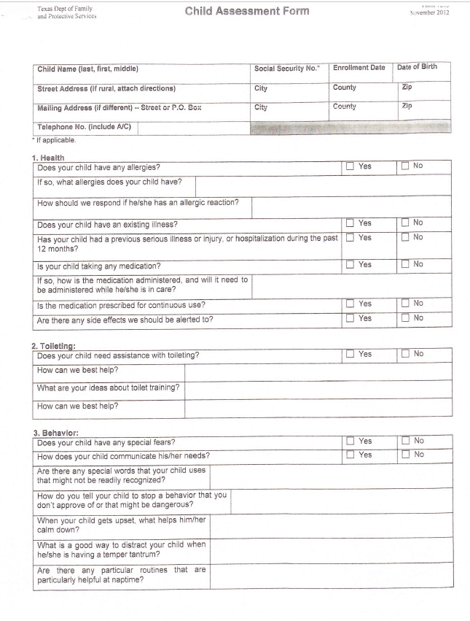
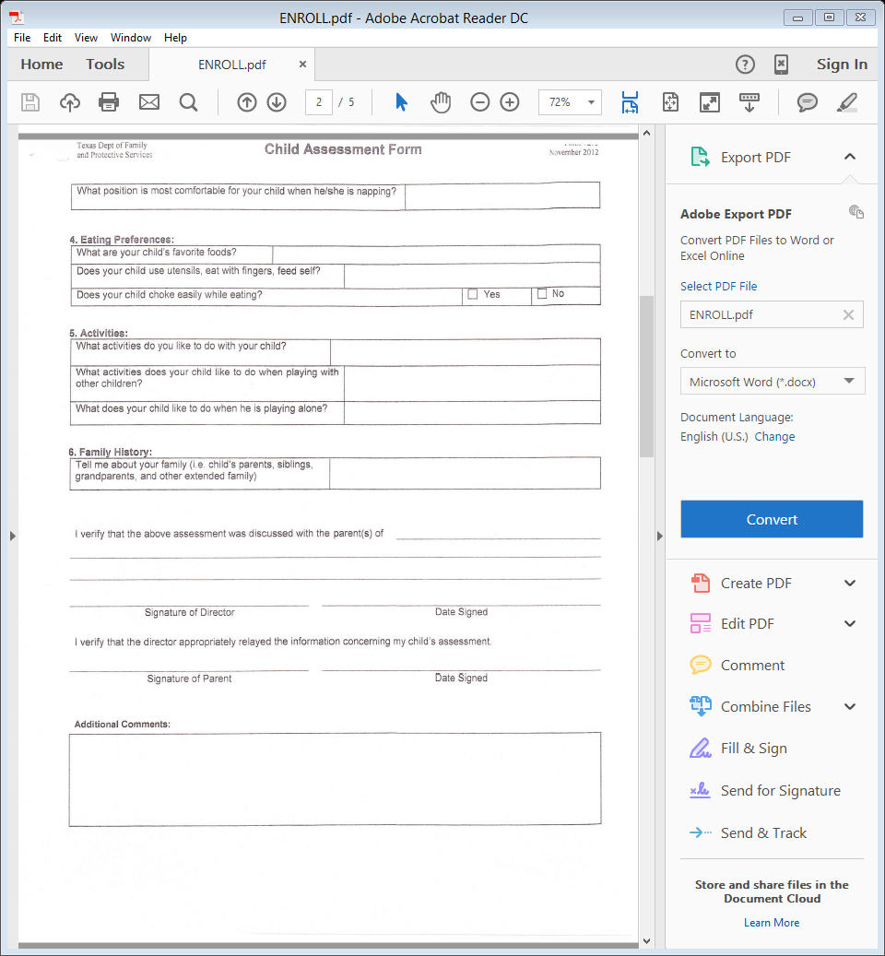

Dear Parents,
At Think Play Grow Academy, we are constantly looking at ways to improve on the service we provide you and your children. With this in mind, we are now moving to mandatory automated tuition and fee payments.

Tuition Express, part of our ProCare Software management system, allows us to process tuition and fee payments safely, quickly and efficiently, ln a matter of minutes we will accomplish what has taken us hours to complete -- leaving us more time to spend with your children.

Once enrolled in Tuition Express, your tuition and fee payments will be paid automatically and on a schedule that we both agree upon. Think Play Grow Academy can produce a receipt for the payment or you can receive instant email notification by signing up at
www.tuition express.com.
Your personal account information is safe with Tuition Express -- safer, in fact, then paying by check. Automated payments have proven safer than writing checks and eliminate potential check fraud or identity theft

Please look over the attached Frequently Asked Questions. There you will find answers to questions you may have about Tuition Express or automated payments in general, lf you have further questions, don't hesitate to ask.

By completing the enclosed Tuition Express enrollment form, you will help us take a gigantic step forward in our payment processing - a step that will allow us to spend more time with your children and less time processing payments. If you choose not to enroll in Tuition Express you can pay with either cash or cheek.

Tuition Express is convenient for you, efficient for us, but best for your children. Welcome
Aboard!

Sincerely,
Casey Koenen

Think Play Grow Academy
2000 N. 25th Street
Waco, TX 76708

